Hydrogen Production Based on Traditional Dual Fluid Gasification versus Hydrogen from Sorption Enhanced Reforming

S. Müller^{1*}, … , …. , H.Hofbauer¹

1. Vienna University of Technology, Institute of Chemical Engineering - Future Energy Technology,
Getreidemarkt 9/166, 1060 Vienna, Austria
*corresponding author, corresponding.author@tuwien.ac.at

- Introduction and Short Description:

In the past large amounts of easily accessible primary energy resources accompanied by an efficient energy infrastructure enabled the development of pleasant wealth in Europe. At the same time, limited resources in Europe itself led to significant dependency on energy imports. The energy strategy of the European Union for the future aims at pretending secure, safe and affordable energy. Furthermore, the energy strategy includes the utilization of local available resources, a reduction of greenhouse gas emissions and the development of new innovative energy technologies, as new high performance low-carbon technologies.

Dual fluid gasification can be named as a promising technology to support the set energy strategy. Traditional dual fluid gasification enables in comparison with other gasification technologies a favorable product gas composition for the production of several different end products like synthetic natural gas, Fischer-Tropsch diesel, mixed alcohols, methanol, other fuels, basic chemicals and hydrogen. Sorption enhanced reforming enables a further improvement of the gas composition and leads to a high share of hydrogen in the product gas stream. A hydrogen production based on dual fluid gasification could either be realized by the use of a traditional gasification system or by the use of the sorption enhanced reforming process. But so far, the question:

Which setup is favorable for the overall hydrogen output?

has not been answered. The following paper describes the results of investigations comparing a traditional gasification with sorption enhanced reforming with respect to the overall hydrogen output. Within the full paper a precise evaluation of the different hydrogen production process routes is carried out. As a part of this precise evaluation this paper discusses:

- the state of knowledge for both production routes,
  - simulation results investigating the overall hydrogen output,
  - variations of key process parameters identifying primary mechanisms pushing the overall hydrogen productivity,
  - and an interpretation of achieved results with respect to a large scale integration as industrial process.

- Methodology, Results and Discussion

The investigations are based on an intensive literature study, operation data from large scale plants, experimental results and thermodynamic calculations by the use of the simulation software IPSEpro.

Achieved results are illustrated by the aid of mass flow charts and diagrams highlighting the impact of variations of key process parameters. Fig. 1 and Fig. 2 give a rough impression about included illustrations. Additional Tables contain operational data and results of carried out calculations.

- Conclusion and Outlook

The full paper will contain broad results which highlight strengths and weaknesses of hydrogen production based on traditional dual fluid gasification versus hydrogen from sorption enhanced reforming.

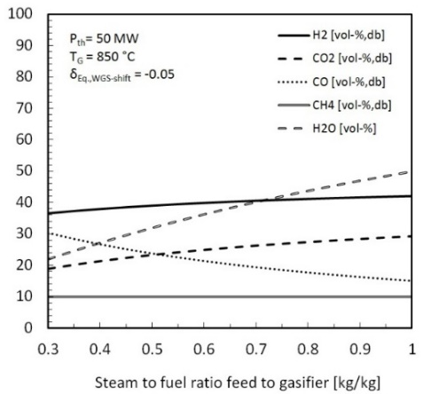

Fig.1: Impact of steam to fuel ratio on hydrogen content in a traditional dual fluid gasifier

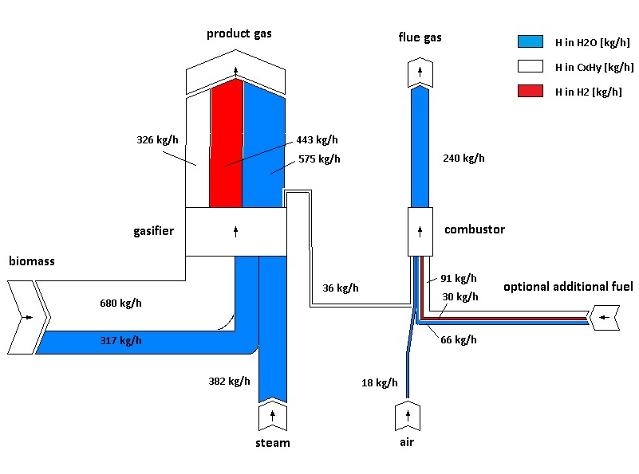

Fig. 2: Hydrogen mass flow chart for a traditional dual fluid gasifier

